**How to Perform Data Analysis in Excel: A Beginner’s Guide**

In this article, we will explore each and everything of Data Analysis in Excel and learn about Data analysis excel.

**Table of Content**

* [Basic Methods of Data Analysis in Excel](https://www.geeksforgeeks.org/data-analysis-in-excel/?ref=outind#methods-of-data-analysis)
* [Advanced Data Analysis Tools in Excel](https://www.geeksforgeeks.org/data-analysis-in-excel/?ref=outind#advanced-data-analysis-tools-in-excel)
* [Essential Excel Functions for Data Analysis](https://www.geeksforgeeks.org/data-analysis-in-excel/?ref=outind#excel-functions-for-data-analysis)

**What is Data Analysis in Excel**

Data analysis is the process of **inspecting, cleaning, transforming, and modeling data** to extract valuable information, uncover patterns, and support decision-making. Using tools like Microsoft Excel for data analysis makes this process accessible and efficient. By leveraging Excel’s advanced features, users can analyze datasets, identify trends, and present insights in a meaningful way.

**Why Excel is Ideal for Data Analysis**

Microsoft Excel is a versatile and user-friendly tool for data analysis because:

* It offers a wide range of functions for statistical and logical calculations.
* Visualization tools like charts and conditional formatting help present data effectively.
* PivotTables and Solver enable advanced analysis for large datasets.

**Preparing Data for Analysis**

Data analysis with Excel is a common and accessible way for individuals and businesses to analyze and visualize data. Microsoft Excel provides a range of tools and functions for performing basic to advanced data analysis tasks. The software enables users to seamlessly import and organize data from various sources, facilitating a structured foundation for Data Analysis Excel.

Data cleaning becomes an intuitive process with Excel’s capabilities, allowing users to identify and rectify issues like missing values and duplicates. PivotTables, a hallmark feature, empower users to swiftly summarize and explore large datasets, providing dynamic insights through customizable cross-tabulations, making Data Analysis Excel an essential skill for professionals.

**Preparing Your Dataset**

Before getting into analysis, it’s essential to clean and organize your dataset to ensure accuracy.

**How to Clean Data in Excel**

1. **Remove Duplicates:** Use **Data > Remove Duplicates** to eliminate redundancy.
2. **Use TRIM and CLEAN Functions:**
   * TRIM removes unnecessary spaces.
   * CLEAN removes non-printable characters.
3. **Sort and Structure Data:** Convert your dataset into an Excel Table (**Insert > Table**) for better organization.

**Basic Methods of Data Analysis in Excel**

Excel offers several methods to analyze data effectively. Here are some key techniques:

**1. Charts and Visualization**

Any set of information may be graphically represented in a chart. A chart is a graphic representation of data that employs symbols to represent the data, such as bars in a bar chart or lines in a line chart. Data Analysis Excel offers several different [chart types](https://www.geeksforgeeks.org/types-of-charts-in-excel/) available for you to choose from, or you can use the Excel Recommended Charts option to look at charts specifically made for your data and choose one of those.

Charts make it easier to identify trends and relationships in your data:

* Select your dataset and go to **Insert > Charts**.
* Choose from bar charts, line charts, or pie charts.
* Customize the chart for clarity and impact.

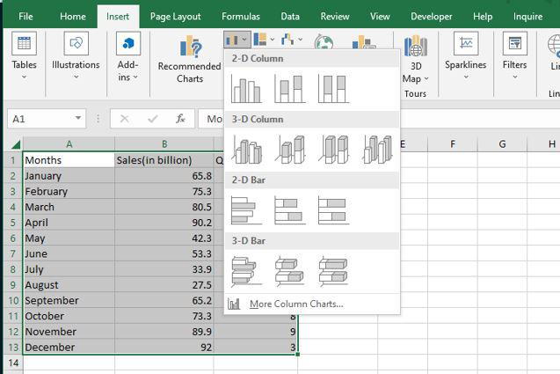

Preview Chart

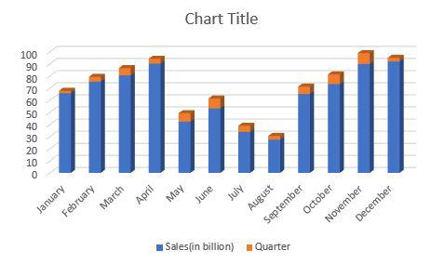

*Bar Graph*

**2. Conditional Formatting**

Patterns and trends in your data may be highlighted with the help of conditional formatting. To use it in Data Analysis Excel, write rules that determine the format of cells based on their values. In Excel for Windows, conditional formatting can be applied to a set of cells, an Excel table, and even a PivotTable report. To execute conditional formatting, follow the below steps:

**Step 1: Go to Home > Conditional Formatting.**

Select any column from the table. Here we are going to**select a Quarter column.**After that go to the **home tab**on the top of the ribbon and then in the**styles group select conditional formatting**and then in the**highlight cells rule select Greater than an option.**

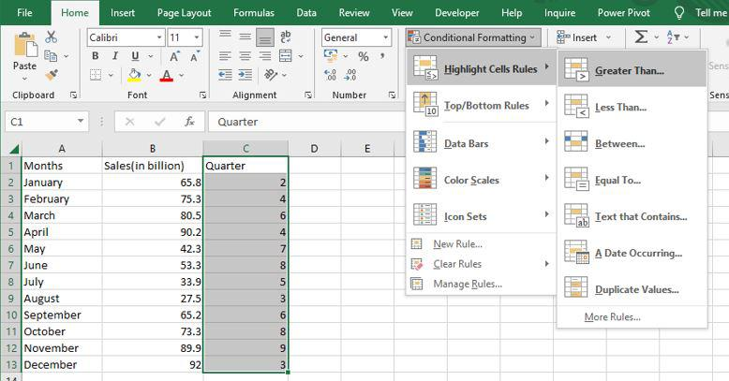

Then a **greater than**dialog box appears. Here first **write the quarter value and then select the color.**

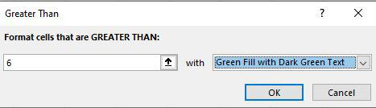

**Step 2: Preview Result**

As you can see in the excel table **Quarter column change the color of the values that are greater than 6.**

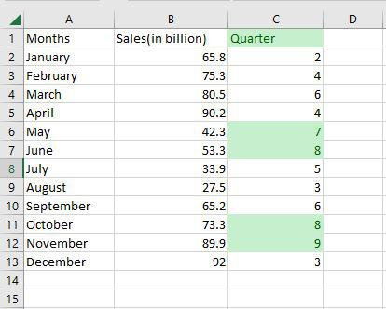

**3. Sorting Data**

Data analysis Excel requires sorting the data. A list of names may be arranged alphabetically, a list of sales numbers can be arranged from highest to lowest, or rows can be sorted by colors or icons. Sorting data makes it easier to immediately view and comprehend your data, organize and locate the facts you need, and ultimately help you make better decisions. Both columns and rows can be used to sort. You’ll utilize column sorts for the majority of your sorting. By text, numbers, dates, and times, a custom list, format, including cell color, font color, or icon set, you may sort data in one or more columns.

* **Single Column:** Sort data alphabetically or numerically using **Data > Sort**.
* **Multiple Columns:** Perform multi-level sorting by adding criteria in the sort dialog box.

**Step 1: Select Data > Data Tab> Sort**

Select any column from the table. Here we are going to**select a Months column.**After that go to the **data tab** on the top of the ribbon and then in the**sort and filters group select sort.**

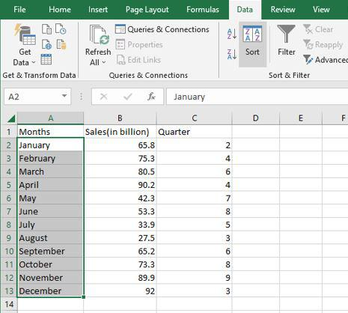

**Step 2: Select the Order**

Then a**sort dialog box**appears. Here first select **the column, then select sort on, and then Order.**After that click OK.

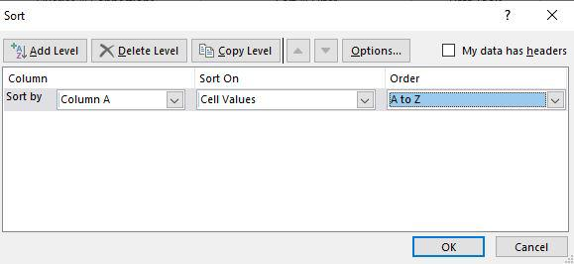

**Step 3: Preview Results**

Now as you can see the**months column is now arranged alphabetically.**

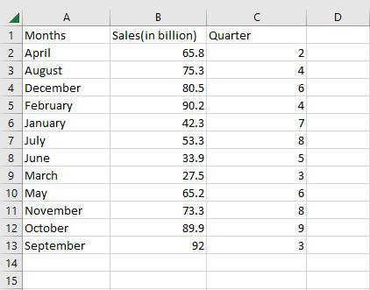

**4. Filtering Data**

You may use filtering to pull information from a given Range or table that satisfies the specified criteria in data analysis excel. This is a fast method of just showing the data you require. Data in a Range, table, or PivotTable may be filtered. You may use Selected Values to filter data. You may adjust your filtering options in the Custom AutoFilter dialogue box that displays when you click a Filter option or the Custom Filter link that is located at the end of the list of Filter options.

**Step 1: Select your dataset and go to Data > Filter**

Select any column from the table. Here we are going to**select a Sales column.**After that go to the**data tab**on the top of the ribbon and then in the **sort and filters group select filter.**

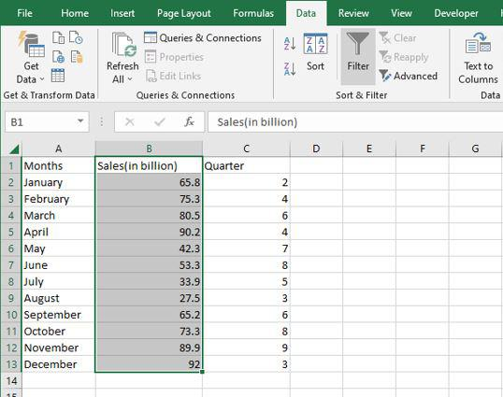

**Step 2: Select the Filter Option**

The values in the sales column are then shown in a drop-down box. Here we are going to **select a number of filters and then greater than.**

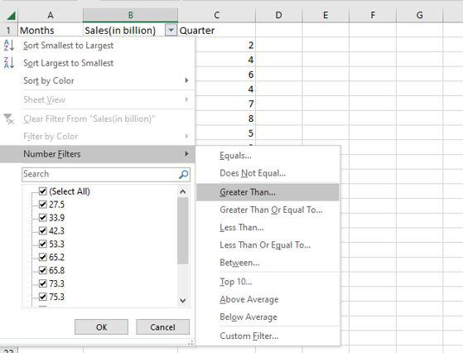

**Step 3: Select the Options**

Then a**custom auto filler** dialog box appears. Here we are going to **apply sales greater than 70**and then click OK.

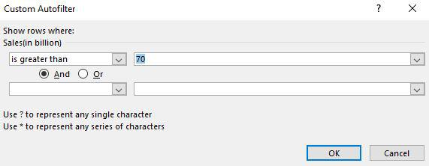

**Step 4: Preview Results**

Now as you can see **only the rows greater than 70** are shown.

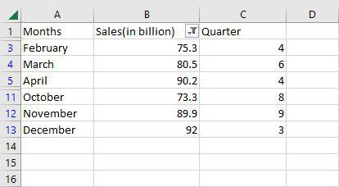

**Advanced Data Analysis Tools in Excel**

Excel offers several advanced tools to make data analysis more efficient and powerful. Here are some key tools you can use:

**1. Power Query**

* Automates data preparation by importing, transforming, and combining data from multiple sources.
* **Example:** Clean and merge datasets to create a unified report.

**2. Data Analysis ToolPak**

* Provides advanced statistical analysis tools like regression and ANOVA.
* **Example:**Use regression to identify relationships between variables or ANOVA to analyze variance across groups.

**3. Solver**

* Optimizes complex problems by finding the best solution based on constraints.
* **Example:** Minimize inventory costs while meeting demand by adjusting stock levels.

These tools help enhance Excel’s capabilities for advanced data analysis, making it suitable for more sophisticated tasks.

**Essential Excel Functions for Data Analysis**

Excel’s built-in functions allow for quick calculations and summaries:

[**LEN**](https://www.geeksforgeeks.org/excel-string-functions-left-right-mid-len-and-find/#len-function-in-excel:~:text=know%20the%20length-,How%20to%20use%20LEN%20Function%20in%20Excel,-Step%201%3A)

=LEN quickly returns the character count in a given cell. The =LEN formula may be used to calculate the number of characters needed in a cell to distinguish between two different kinds of product Stock Keeping Units, as seen in the example above. When trying to discern between different Unique Identifiers, which might occasionally be lengthy and out of order, LEN is very crucial.

***=LEN(Select Cell)***

**Step 1:** If we want to see the**length of cell A2,** for that we need to **write the function of length.**

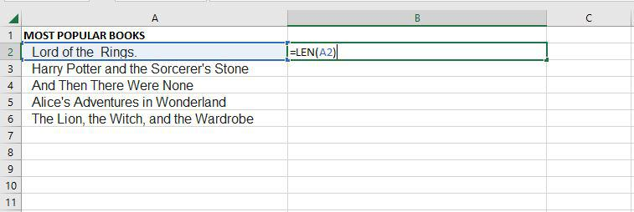

**Step 2:**Now as you can see it **shows the length of the cell A2.**

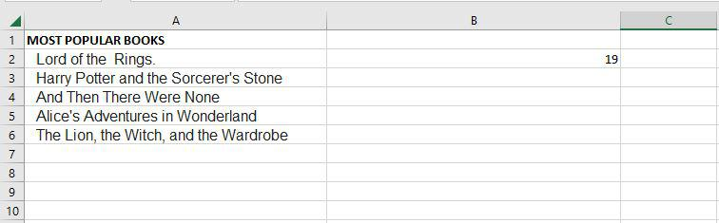

[**TRIM**](https://www.geeksforgeeks.org/how-to-remove-spaces-in-excel/#:~:text=Remove%20in%20Excel-,How%20to%20Remove%20Blank%20Spaces%20Using%20TRIM%20Function,-To%20use%20the)

=TRIM function will remove all spaces from a cell, with the exception of single spaces between words. The most frequent application of this function is to get rid of trailing spaces. When content is copied verbatim from another source or when users insert spaces at the end of the text, this is normal.

***=TRIM(Select Cell)***

**Step 1:** If we want to **remove all spaces from cell A2**, for that we need to write the function of trim.

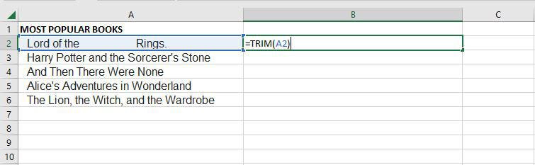

**Step 2:**Now as you can see after **using the trim function, it removes all spaces.**

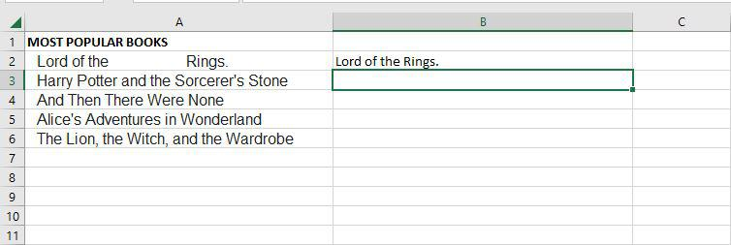

[**UPPER**](https://www.geeksforgeeks.org/how-to-change-the-case-of-texts-in-microsoft-excel/#:~:text=and%20PROPER()%20functions.-,UPPER()%20Function,-This%20function%20takes)

The Excel Text function “**UPPER Function**” will change the text to all **capital letters (UPPERCASE)**. As a result, the function changes all of the characters in a text string input to upper case.

***=UPPER(Text)***

**Text (mandatory parameter):**This is the text that we wish to change to uppercase. Text can relate to a cell or be a text string.

**Step 1:**If we want to **convert the A2 cell to upper text,** for that we need to write the upper function.

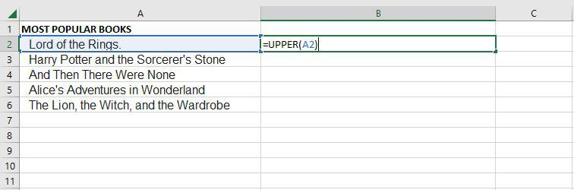

**Step 2:** Now as you can see after using the upper function, **the text is changed to the upper text.**

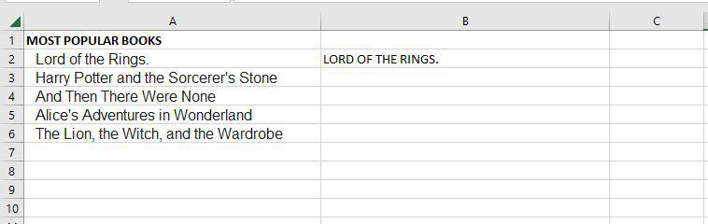

**PROPER**

Under Excel Text functions, the PROPER Function is listed. Any subsequent letters of text that come after a character other than a letter will also be capitalized by PROPER.

***=PROPER(Text)***

**Text (mandatory parameter):** A formula that returns text, a cell reference, or text in quote marks must surround the text you wish to partly capitalize.

**Step 1:** If we want to **convert the A2 cell to proper text,** for that we need to write the proper function.

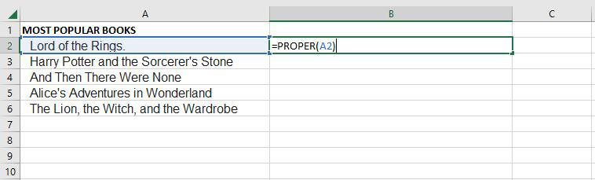

**Step 2:** Now as you can see after using the proper function,**the text is changed to the proper form.**

7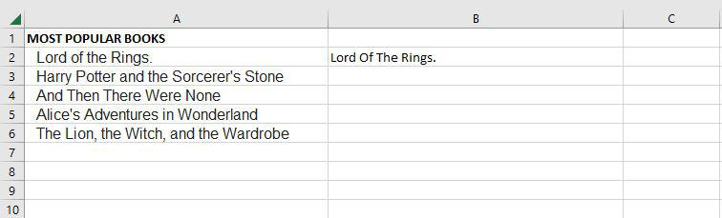

The PROPER function changes the initial letter of every word, letters that follow digits, and other punctuation to uppercase. It could be where we least expect it. The characters for numbers and punctuation remain unaffected.

[**COUNTIF**](https://www.geeksforgeeks.org/countif-function-in-excel-with-examples/)

Excel has a built-in function called COUNTIF that counts the given cells. The COUNTIF function can be used in both straightforward and sophisticated applications in data analysis excel. The fundamental application of counting particular numbers and words is covered in this.

***=COUNTIF(range,criteria)***

* ***Range:****The size of the cell range to count.*
* ***Criteria:****The standards by which cells are selected for counting.*

**Step 1:** Use the**COUNTIF function on the range B2:B20**to get the number of regions we have of each type.

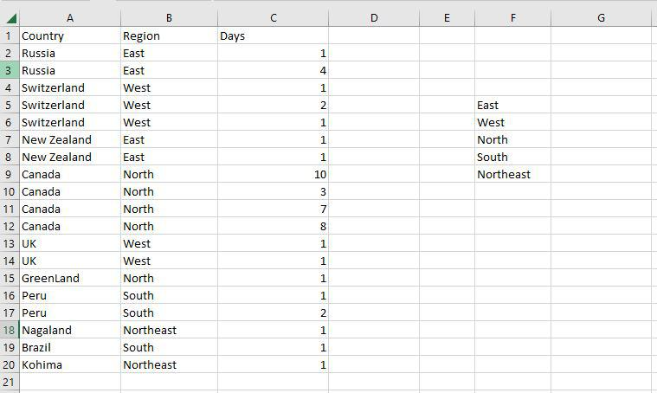

**Step 2:** The **COUNTIF function** will now be used to count the **different sorts of Regions in the range F5:F9.**

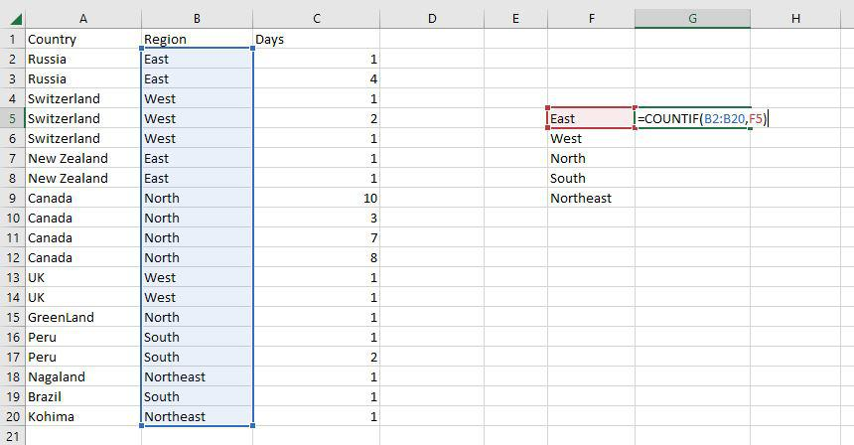

**Step 3:** Now as you can **see the 4 East Region has been correctly enumerated**using the COUNTIF function.

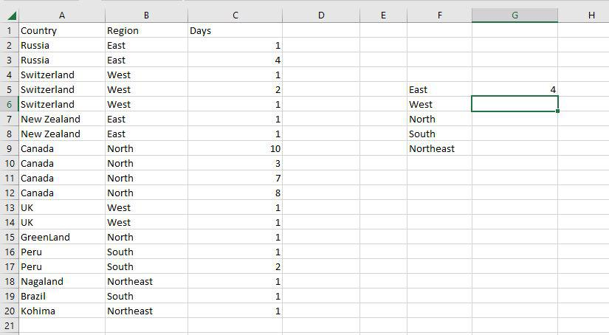

[**AVERAGEIF**](https://www.geeksforgeeks.org/how-to-calculate-average-mean-in-excel/#:~:text=the%20AVERAGE%20function.-,Excel%20AVERAGEIF%20Function,-To%20calculate%20the)

An Excel built-in function called AVERAGEIF determines the average of a range depending on a true or false condition.

***=AVERAGEIF(range, criteria, [average_range])***

* ***Range:****The size of the cell range to count.*
* ***Criteria:****The standards by which cells are selected for counting.*
* ***Average Range:****The range in which the function computes the average is known as the average range. But the average range is not required.*

**Step 1:** Use the **AVERAGEIF function on the range B2:B10**to get the average speed of vehicles.

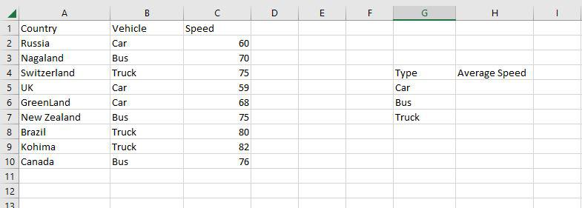

**Step 2:** The AVERAGEIF function will now be used to find the **average of Vehicles in the range H4:H7.**

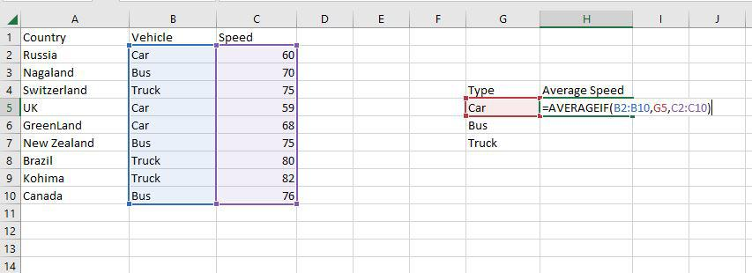

**Step 3:** Now as you can see the**62.333 Car average has been correctly enumerated** using the AVERAGEIF function.

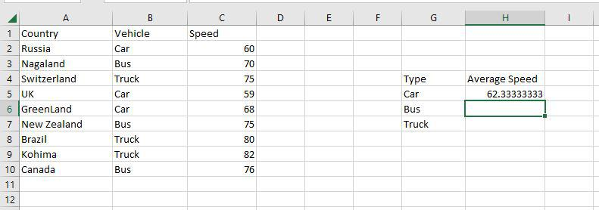

[**SUMIF**](https://www.geeksforgeeks.org/exce-sumif-function/)

A built-in Excel function called SUMIF determines if a condition is true or false before adding the values in a range.

***=SUMIF(range, criteria, [sum_range])***

* ***Range:****The size of the cell range to count.*
* ***Criteria:****The standards by which cells are selected for counting.*
* ***Sum Range:****The range that the function uses to calculate the total is known as the sum range.*

**Step 1:** Use the **SUMIF function on the range B2:B10** to get the sum of the vehicle’s speed.

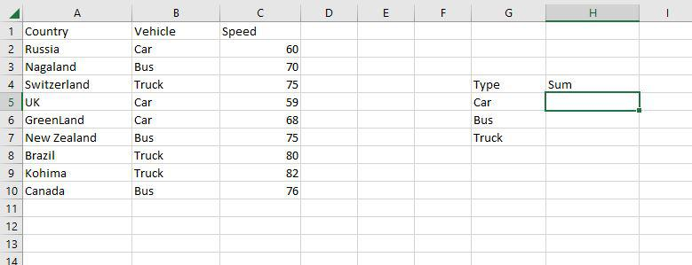

**Step 2:** The SUMIF function will now be used to**find the sum of Vehicles’ speed in the range H4:H7.**

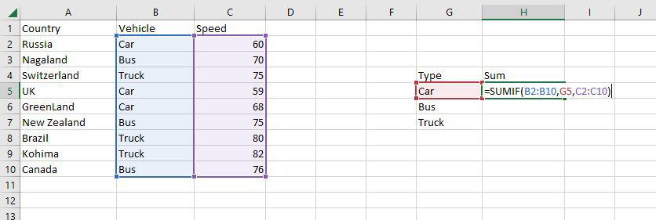

**Step 3:** Now as you can see the**187 Car sum has been correctly enumerated**using the SUMIF function.

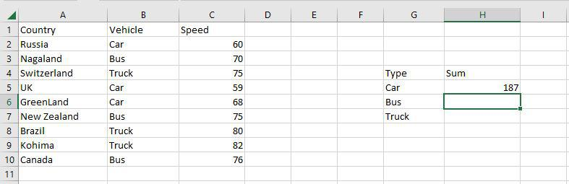

[**VLOOKUP**](https://www.geeksforgeeks.org/use-vlookup-in-excel-guide/)

VLOOKUP is a built-in Excel function that permits searching across several columns.

***=VLOOKUP(lookup_value, table_array, col_index_num, [range_lookup])***

* ***Lookup_value:****Choose the cell that will be used to input the search criteria.*
* ***Table_array:****The whole table range, which includes each and every cell.*
* ***Col_index_num:****The information being searched for. The column’s number, starting from the left, is the input.*
* ***Range_lookup:****FALSE if text (0), TRUE if numbers (1).*

**Step 1:** To locate the**Festival names depending on their search ID, use the VLOOKUP function.**The Festival names in this instance are determined by their search ID.

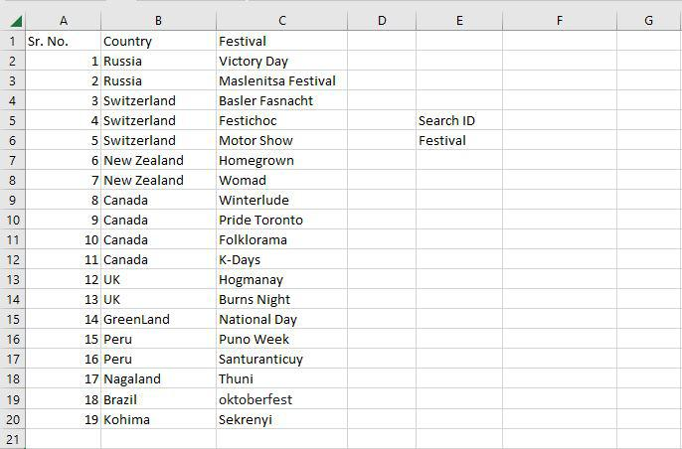

**Step 2: F5 was chosen as the lookup value**. The search query is typed in this cell. Table array, in this case, **A2:C20, is designated as the table’s range.** The **col index number is set to 3,** which is entered. The information being searched is in the third column from the left. **Range lookup is entered as 0 (False).**

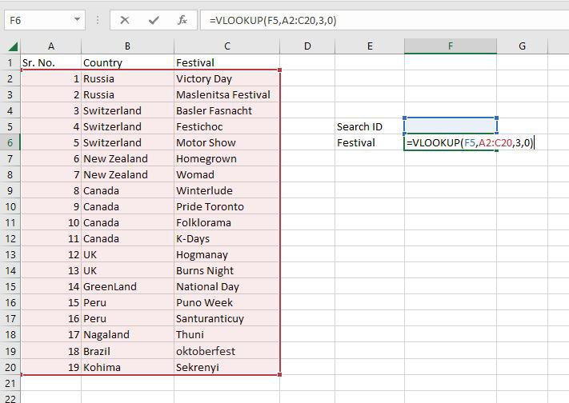

**Step 3:** The **#N/A value is what the function returns.** This is the result of the Search ID F5 having no value entered.

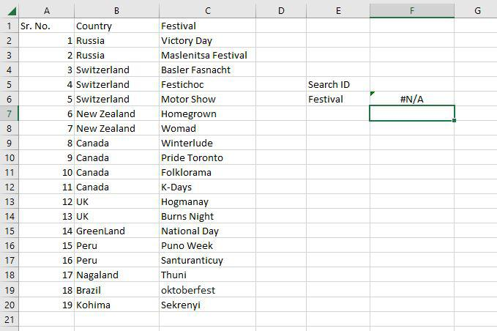

**Step 4:** The **Homegrown Festival**, which has **Search ID 6, has been located through the VLOOKUP tool.**

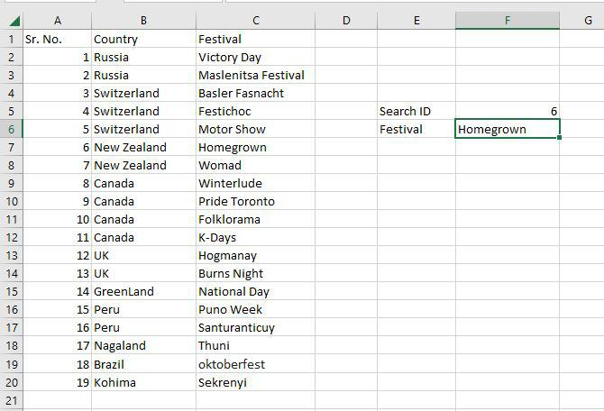

[**Pivot Table**](https://www.geeksforgeeks.org/pivot-tables-in-excel/)

In order to create the required report, a pivot table is a statistics tool that condenses and reorganizes specific columns and rows of data in a spreadsheet or database table. The utility simply “pivots” or rotates the data to examine it from various angles rather than altering the spreadsheet or database itself.

**Step 1:**Select any cell and then**go to the home tab and then select Pivot table.**

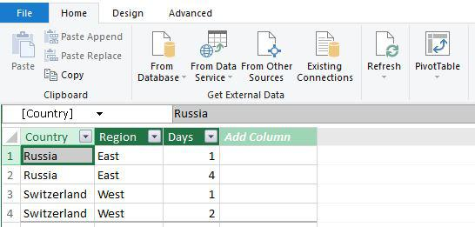

**Step 2:** Create**Pivot table dialog box appears** here select the**new worksheet and then click OK.**

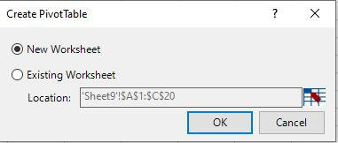

**Step 3:** Now you can **see it creates a pivot table.**

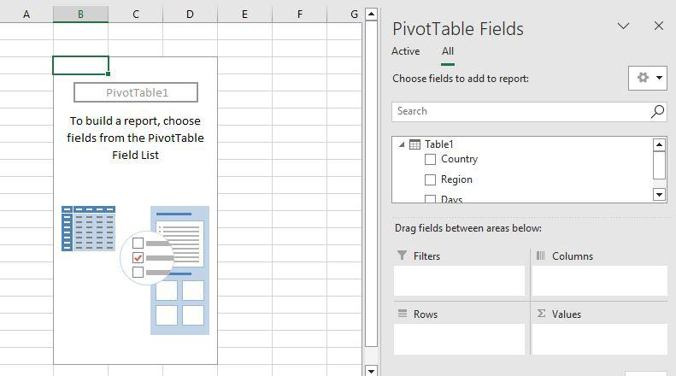

**Step 4:** Just drag the**Country field to the row area** and the **Days field to the value area.**

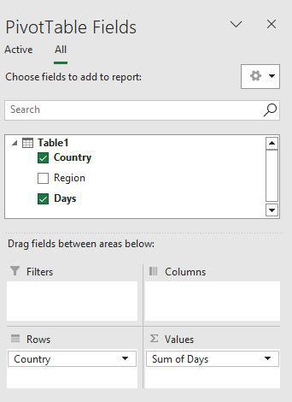

**Step 5:** Now you can see the **proper pivot table with Country and days fields.**

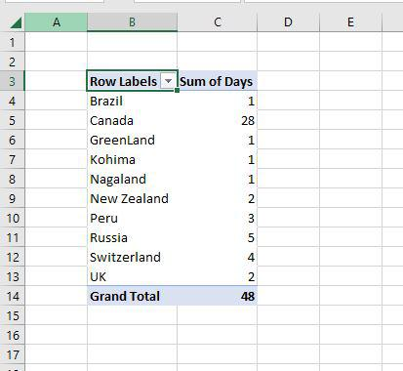

***Also Read:***

* [*How to Create PivotTables in Excel*](https://www.geeksforgeeks.org/pivot-tables-in-excel/)
* [*Top Excel Data Analysis Functions*](https://www.geeksforgeeks.org/excel-data-analysis-function-that-you-can-try/)

**Conclusion**

Mastering **data analysis in Excel** can transform how you work with information, making it easier to identify patterns, make decisions, and share insights. By using features like charts, conditional formatting, and advanced functions, you can navigate and analyze datasets efficiently. Take advantage of Excel’s rich toolkit, including **Data Analysis Excel tools** and Pivot Tables, to enhance your data storytelling. Dive in and explore how Excel empowers you to extract meaningful insights from your data.